First low fi prototype and final outcome

Content-collection

Contact

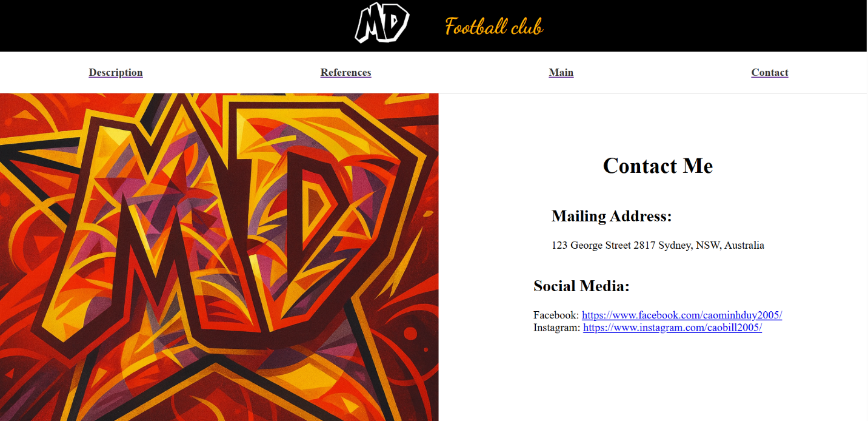

Description

Index

References

